***Flow chart***

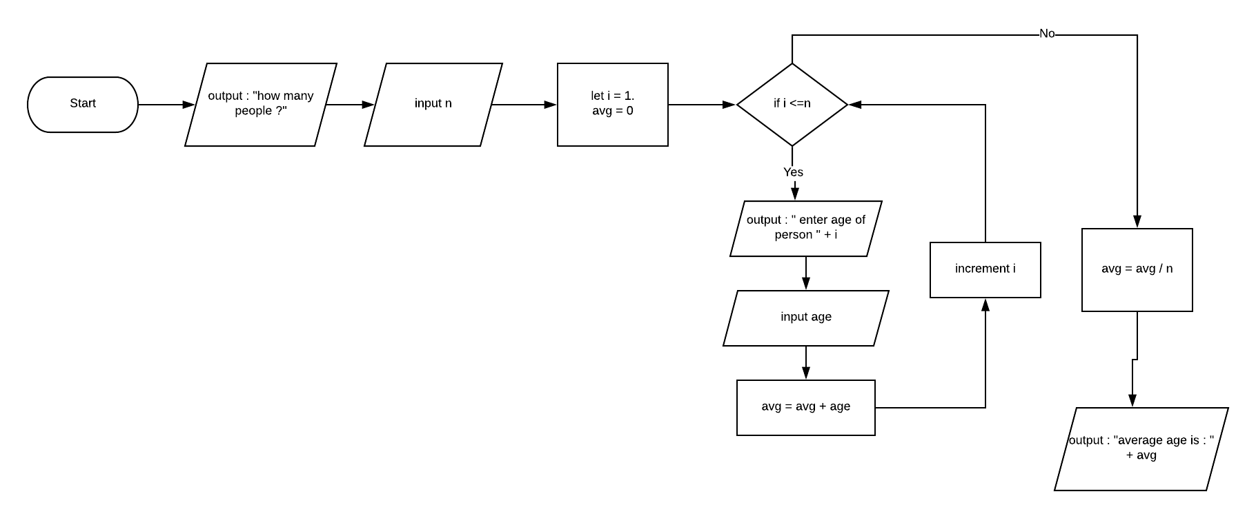

***Pseudocode***

1. Declare x
2. Declare i
3. Declare avg
4. Declare age
5. Output : “ how many people ?”
6. Input n
7. Set i = 1
8. Set avg = 0
9. For (i = 1; i <=n ;) {
10. Output : “enter age of person “ + i
11. Input age
12. Avg = avg + age
13. I++
14. LOOP
15. avg = avg / x
16. Output : “average age is “ + avg
17. END

Trace 1

|  |  |  |  |  |  |  |
| --- | --- | --- | --- | --- | --- | --- |
| Line no. | Input buffer | x | i | Avg | age | Output buffer |
| 1. | - | - | x | x | x | - |
| 2. | - | - | - | x | x | - |
| 3. | - | - | - | - | x | - |
| 4. | - | - | - | - | - | - |
| 5. | - | - | - | - | - | “How many people” |
| 6. | 4 | 4 | - | - | - | - |
| 7. | - | 4 | 1 | - | - | - |
| 8. | - | 4 | 1 | 0 | - | - |
| 9. | - | 4 | 1 | 0 | - | - |
| 10. | - | 4 | 1 | 0 | - | “Enter age of person “ + i |
| 11. | - | 4 | 1 | 0 | 24 | - |
| 12. | - | 4 | 1 | 24 | 24 | - |
| 13. | - | 4 | 2 | 24 | 24 | - |
| 9. | - | 4 | 2 | 24 | - | - |
| 10. | - | 4 | 2 | 24 | - | “Enter age of person “ + i |
| 11. | - | 4 | 2 | 24 | 26 | - |
| 12. | - | 4 | 2 | 50 | 26 | - |
| 13. | - | 4 | 3 | 50 | 26 | - |
| 9. | - | 4 | 3 | 50 | - | - |
| 10. | - | 4 | 3 | 50 | - | “Enter age of person “ + i |
| 11. | - | 4 | 3 | 50 | 25 | - |
| 12. | - | 4 | 3 | 75 | 25 | - |
| 13. | - | 4 | 4 | 75 | 25 | - |
| 9. | - | 4 | 4 | 75 | - | - |
| 10. | - | 4 | 4 | 75 | - | “Enter age of person “ + i |
| 11. | - | 4 | 4 | 100 | 25 | - |
| 12. | - | 4 | 4 | 100 | 25 | - |
| 13. | - | 4 | 5 | 100 | 25 | - |
| 14. | - | 4 | 5 | 100 | 25 | - |
| 15. | - | 4 | 5 | 25 | 25 | - |
| 16. | - | 4 | 5 | 25 | 25 | “Average age is” + avg |
| 17. | - | 4 | 5 | 25 | 25 | “Average age is” + avg |